Hello Old Exmothians

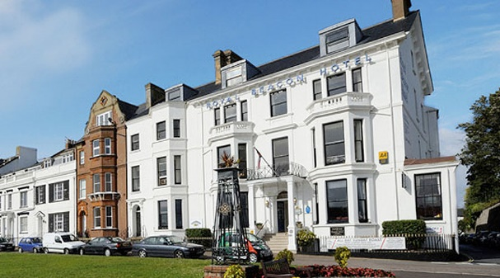
The Royal Beacon is our venue once again for this year’s reunion. This year my year group celebrates 70 years since we first joined EGS, so it is our Platinum Jubilee!

After much heart searching and talking to many friends, we have reluctantly decided this year will be our last general reunion. Sadly, we have lost nearly a dozen friends this year, not least David West, who you all know was so instrumental in continuing the reunions. Our numbers are inevitably diminishing. To celebrate our extraordinary run of 38 years of reunions in the present form, the cost this year will be subsidized by the past membership fees.

Having Mr. Cooksley’s magazines has given me a unique insight into those Reunions where there was much more formality; Mr. Johnson presiding over meetings, Christmas Dances, and Annual Dinners. Many of our peer group were members of the committee.

Beginning in the 1980s, I was able to attend all but the first meeting, and I have been involved with the background organization since Doug Robertson co-opted David and I to help him over 20 years ago. David took up the challenge when Doug sadly died and made me his ‘Chief Underling’. I have been privileged to work with both Doug and David, and to be in touch with all you lovely, loyal, reunion friends. My good fortune was also having Deirdre as my fellow organizer. Thank you for keeping me on the straight and narrow, for supporting the reunions, and for your friendship!

The hotel is once again offering a 10% discount for those planning to stay overnight. When you book, please let the hotel know you are attending the reunion.

A buffet supper will be provided. For those planning to attend and enjoy the buffet please detach the form at the bottom and send it to either Elaine or Deirdre (addresses overleaf), together with a cheque as appropriate. The cost this year will be £7.

We need to pay the hotel two weeks in advance, so early notification of your attendance will be appreciated.

If you intend to join us but do not wish to partake of the buffet, please let us know as we like to have the details for our badges. Thank you.

Completion of the form will allow us to update your details on our database and make any necessary changes, especially if you have a new postal or email address.

If you are in touch with any former pupils who have not attended our reunions, please let us know their details and we will send them an invitation.

We hope as many of you can attend as possible, and we look forward to meeting you again, or for the first time.

Regards
Elaine and Deirdre

CONTACTS:
Elaine Bagnall:
Old School House  High Street  Kentisbeare  Devon  EX15 2AA | 01884 260121 or 07879 494920
 | elaine@thebagnalls.co.uk
Deirdre Jennings:
Mariners  21 Portland Avenue  Exmouth  Devon  EX8 2BS | 01395 279545
 | deirdre.jennings@talktalk.net
Royal Beacon Hotel:
The Beacon  Exmouth  Devon  EX8 2AF | 01395 224488 or 0800 0052244
 | reservations@richardsonhotels.co.uk

I/We wish to attend the function on Friday 6th October 2023 from 7.00pm for 7.30pm. A payment of £____ is enclosed for ____ guests at £7 each.
Please make cheques payable to Exmouth Grammar School Reunion.
Name (Male) |  |  | Address (including Post Code)
Years Attended
School House
Name (Female)
Maiden Name
(if applicable)
Years Attended |  |  | Email address
School House |  |  | Home phone
Guest Name |  |  | Mobile phone
Special Dietary Requirements

